# Introduction

This manual will help you configure and deploy the automatic updates for Cam Content Mover.

This wizard when run will create the following resources:

In Azure Tenant will create:

* Azure AD Application
* Resource Group in the Selected Subscription
* Will set the Resource Group permissions of Owner for the principal created in the first bullet of this process.

In Azure Devops Tenant will create:

* Will create a Project in Azure Devops
* Will create a Repo with the ARM templates and needed files for the deployments
* Will create two service connections, one to deploy the ARM template to Azure and one to report the success or failure of the process to Prosperoware.
* Will Create a pipeline for the ARM Template
* Will create a Release for the ARM Template
* Will create a pipeline for the functions
* Will create the releases for the functions

# Requirements

To run the Wizard, you will the following:

* Azure tenant with Admin Privileges
  + In case you are going to deploy to an already existing RG. The user running the Wizard needs to be owner of the Resource Group
* Azure Deveops Tenant
  + Azure Devops url in the form <https://dev.azure.com/organization>
  + Mail of an azure Devops user that already exists in the Azure Organization to be the owner of the project and deployments
  + In the case of configuring a user to authorize the deployments you will need to the email of this user. It could be the same as the owner
  + Two Pats Created by and user with Azure Devops Tenant with Project Collection Administration permissions.
* Prosperoware Tenant information:
  + Prosperoware Tenant Id
  + Prosperoware Encrypted Key
  + Prosperoware Secret Key

# Deployment and usage of the Wizard

1. Start wizard, after the verification of your equipment finish you will see the following screen

1. Select the type of the deployment you want Standard or Premium you can see more information in https://pdocs.atlassian.net/wiki/spaces/CCAM/pages/1058209793/Moving+from+Azure+Standard+to+Premium
2. Log into azure using an admin account
3. After login you will see the available Tenants and subscriptions for your account

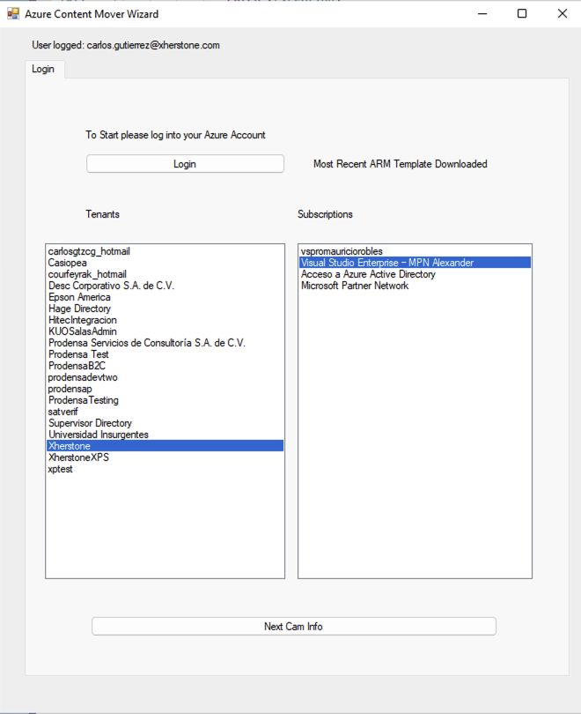

Select the Tenant and the subscription where you want to deploy and click on “Next Cam Info”

1. Fill all the information in the Cam Data step

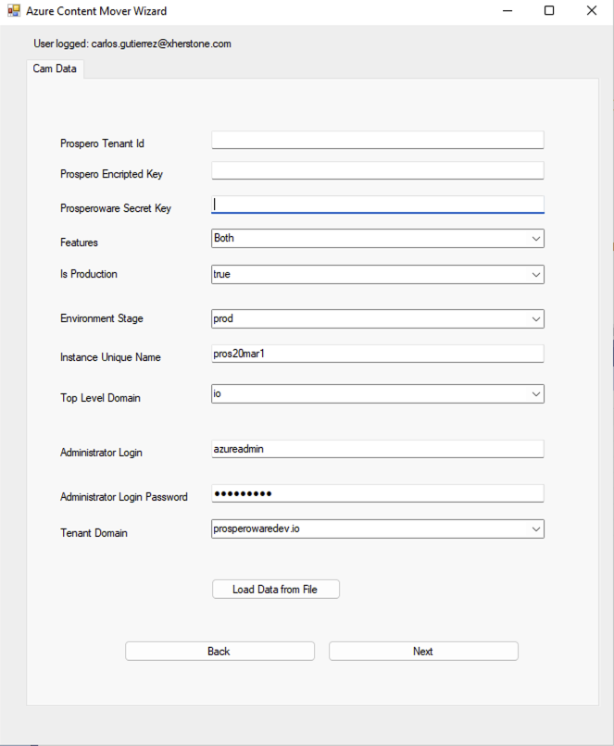

And click on next, this will check that the information provided is correct and if so, it will present the Azure Devops form.

1. Fill the information of your azure devops Tenant

Here you can select if you want an automatic deployment every time a new release has been push, or if you want a user to approve.

If you want a user to approve select the “add pre deployment approver” and fill the user email.

You won’t be able to continue unless you provide valid emails and that emails exists on the Azure Devops Tenant indicated.

When you are ready click on next, this will check that the information you provided is accurate and if so it will present the next step.

1. Select the region where you want the deploy to create the new resource group, or if you already have a resource group created check the “Existing Resource Group” and select the resource group where you want the deployment to take place.

**WARNING. If you select and already existing RG you should be sure that if a current implementation of Content Mover is the same as the one that will be automated. If you have a standard deployed and try to deploy premium the process will fail, the same if you try to deploy standard to a RG where a premium deploy was already deployed. In both cases the current implementation will stop working and will have to be re deploy.**

1. Click on the “Select Cache folder” button, and select an EMPTY folder to be used as a cache. This folder should be as closed as possible to the root of your HD or it may failed.
2. Click on start and fill the login credentials. Be sure to used the same credentials you used in the first step of the wizard.

1. Wait until the wizard finish, this could take several minutes, do not allow your screen to be blocked or shutdown. Be aware that the step “Download most recent code” and “Pushing function code” could potentially take several minutes depending on you internet speed.
2. When the wizard finish go to your azure devops tenant and look for the project with the name you select in the step “Azure Devops”
3. In your azure devops tenant go to “Pipelines” and fire the pipeline named “pipeline-azure-contentmover”.
4. If you select the “Add pre deployment approval” in the Azure Devops Section, wait until an email arrives to the user account and accept the Deployment, if you did not, go to the next step

The email the user will received will look like this

Click on “View approval”

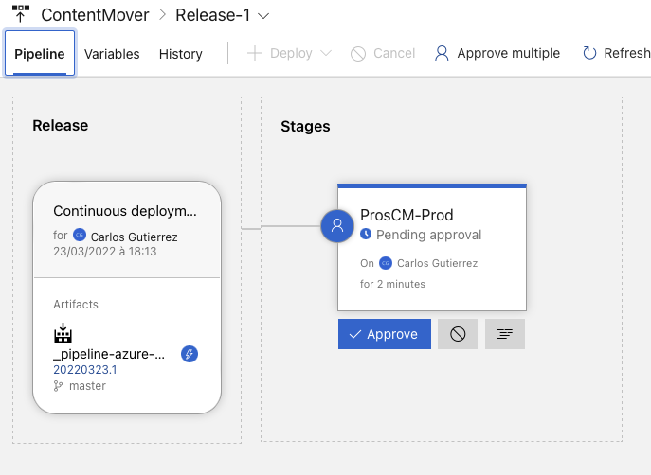

Select “Approve”

1. Go to the Release section and look for a Release named “ContentMover” and wait until it finished.

1. Once finished in green Status go to pipelines and start the pipeline “Functions”

When it finish go to the releases tab and wait until the functions releases finish.

# Possible errors in ARM Template

## Error in arm template . There is a deployment currently in progress

This error is mostly generated in the premium template.

If you see this error, just redeploy using azure devops

## Error There is a deployment currently in progress. Please try again when it completes.

{

    "status": "Failed",

    "error": {

        "code": "BadRequest",

        "message": "There is a deployment currently in progress. Please try again when it completes."

    }

}

When you have this error just retry the deployment job.

# Fire ensure ensureInitialConfig

In the premium deployment if you need to invoke the “ensureInitialConfig” function you will need to open the firewall for your pc’s ip. If you try to invoke it with out the following configuration you will get the next error:

To Fix this follow the next steps:

1. Find out your ip address.
2. Once you have your ip address go to the Azure portal, look for you RG implementation and get into the “etl-config” function configuration, for example:

1. Then go to Networking, and Access Restriction

1. One in access restriction hit add rule and add you ip address. After this you will be able to call the “ensureInitialConfig” endpoint. When finish delete your ip if necessary.